CLIENT DASHBOARD
VAT bug on Stripe Checkout:
Stripe is charging 0% VAT on a $25 order to a Romanian consumer. This is illegal — tyes LLC (US) selling digital services to EU consumers MUST charge destination VAT under OSS Non-Union scheme (19% for RO = ~RON 22 missing per sale).
Also missing: the "Add VAT number / Purchase as business" field is gone from Stripe Checkout — business customers can't reverse-charge.
Fix (one dev change): enable in Stripe Checkout session config:
- automatic_tax: { enabled: true }
- tax_id_collection: { enabled: true }
Plus turn on Stripe Tax + OSS EU registration in the Stripe Dashboard.
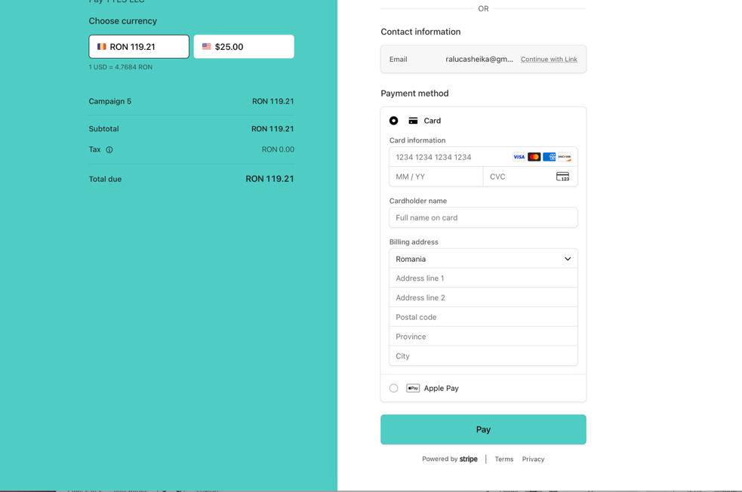

• Filter counts are broken — tabs show "In Progress (6) · Revision (6) · Delivered (6)" but total = 6 orders. Every count can't equal total; each order is in exactly one state. Filter logic is showing total-count for every tab.
• Weird date on new order — ORD-E6EA shows date 2026-09-17 but today is 2026-09-18 (server timezone drift, minor).
• Old Overview issue reconfirmed: tie that card explicitly to an order id so users know which of their orders is generating it.

